**International Marketing Strategy of Tesco**

**International marketing**

**BU7411**

**Sue Ollerhead**

**Word Count - 4000**

**Student Assessment Number (J Number)**

**Table of Contents**

1. Introduction 1

2. International Market Analysis 2

(i) International market assessment 2

(ii) 2 types of market entry strategy 4

(iii) Impact of market issues on market entry decisions 5

(iv) Most suitable market entry method 7

3. Customer level cross-cultural research and analysis 7

4. Impact of cross-cultural issues on international marketing -mix strategy 12

(i) Promotion strategy 12

(ii) Product strategy 12

(iii) Price strategy 13

(iv) Place strategy 13

5. Conclusion 14

6. Reference 15

7. Appendix 18

# 1. Introduction

The portfolio details the strategies required for market entry and marketing for international brand expansion. Tesco is a multinational brand that wants to foray into Vietnam. Tesco is a multinational company, headquartered in London. It is present across the UK, Hungary, Slovakia, the Czech Republic, and Ireland. It is a significant market player in food wholesalers in the UK. Besides food, the Tesco group provides money services, insurance, and banking through the Tesco bank. It provides wides coverage of mobile virtual networks through Tesco mobile (Tesco Annual Report, 2022). Vietnam is located in South East Asia and enjoys 70 out of 190 countries. Graph available Table A in Appendix (Doing Business Vietnam, 2022).

# 2. International Market Analysis

## (i) International market assessment

**(a) Porter’s 5 Forces Model**

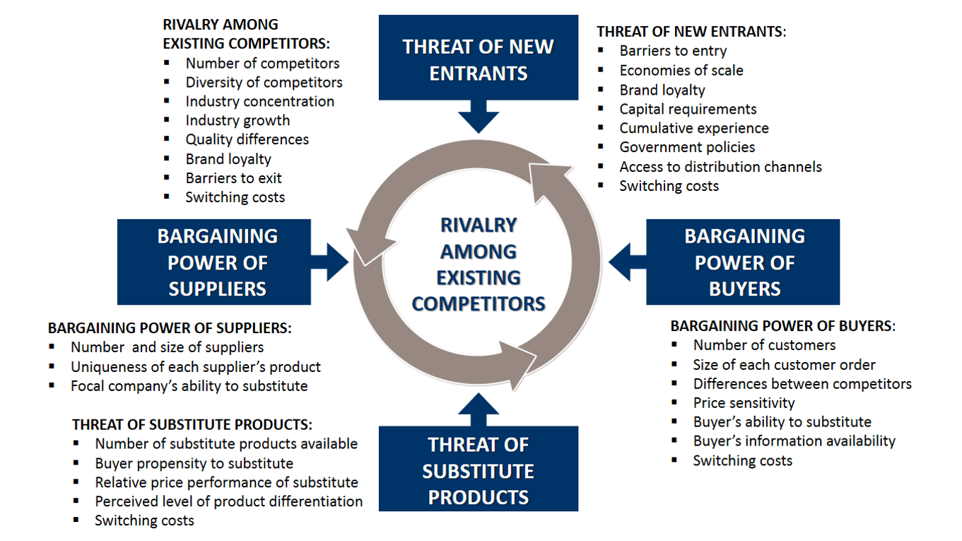

Fig 1: Porter’s 5 Forces Model

(Source: Bruijl, 2018)

|  |  |  |
| --- | --- | --- |
| **Indicators** | **Description** | **Impact** |
| **The threat of new entrants-** | 1. Barriers to entry are substantially low.  2. Capital requirements are high for new businesses/factories in Vietnam.  3 Vietnam has strict policies when setting up new business as it involves obtaining a license.  4. Government policies in Vietnam are liberal when it comes to FDI.  5. Wide presence of small and medium-sized food suppliers. | Medium impact as liberal FDI policy enables foreign players to enter market easily and compete with Tesco |
| **Bargaining power of buyers**- | 1. Number of customers is high.  2. Customer orders are not significantly high, as most prefer to do daily shopping instead of bulk shopping.  3. The difference between competitors is not high enough for a customer’s buying decisions.  4. Customers in Vietnam are price sensitive.  5. There are multiple products to choose from for buyers.  6. Low switching cost. | High impact as there are significantly high number of market players, who can offer products at competitive price. This can lead to price wars affecting profit margin even more during the initial phase of launch. |
| **The threat of substitute products** | 1. A High number of substitute products available.  2. Buyers tend to go for substitutes due to price differences.  3. Vietnam is mainly characterised by many small food sellers.  4. Perceived level of product differentiation by buyers is less.  5. Cost of switching from one substitute to another is significantly less. | Medium impact as substitute products may not match quality and price offered by big retailers. Thus even if the cost of switching is low there can be substantial differences in product quality and price with substitutes. |
| **Bargaining power of suppliers** | 1. Vietnam is characterised by significantly high traditional grocery retailers, then come supermarkets, hypermarkets and convenience stores that order (Grocery Shopping Vietnam, 2022).  2. These stores are supported by thousands of small and medium-sized suppliers.  3. As there are mainly small and medium-sized suppliers the suppliers enjoy less bargaining power.  4. There is no readily available substitute in place of the traditional food supplier’s network for Tesco. | Low impact as there are innumerable mixtures of big, small and medium suppliers. Rivalry among suppliers can bring down the logistic cost for a big retailer like Tesco. |
| **Rivalry among existing competitors** | 1. High degree of rivalry among existing players.  2. There are about 13 competitors in the physical store type shops, about 16 foreign players such as supermarkets, convenience and shopping malls and about 9 competitors in the online store segment (Retail in Vietnam, 2022).  3. Very high degree of diversity both in products offered and price.  4. High degree of concentration in urban locations than rural. The main competitors of Tesco in the urban segment come from medium-sized street shops, small street shops wet markets, and speciality stores. | Mediumas there are only few competitors in the market. Thus one advantage that foreign players like Tesco can utilize in the future, is FDI. Increased FDI will help it expand faster than domestic players. |

## (ii) 2 types of market entry strategy

Based on the assessment of the marketing environment and competitor landscape analysis, in Vietnam, there are two types of marketing entry strategies that Tesco can follow, one is the export strategy and the other is the Greenfield strategy.

(**a) Export Strategy**

Tesco can follow the export strategy of market entry through which it will be able to reach far and wide in the food supply market of Vietnam. The export strategy involves a low initial capital requirement as most of the manufacturing units are present in the parent market (Chen et al., 2019). Tesco will incur logistical costs in this type of strategy. Tesco can use the already existing raw materials supply chain and its manufacturing unit to increase production. This will enable Tesco to enjoy economies of scale through mass production capacity at no significant rise in cost. These finished goods can be sent by air or sea transport depending on whether the item is perishable or not. Once the products reach Vietnam Tesco can ship these products through the designated logistical companies or can use the logistical support of the other competitors present in convenience stores, supermarkets, hypermarkets and medium-sized grocery stores. The drawback of this kind of strategy is Tesco will not have e high degree of control over its product distribution. Besides that, As Tesco does not know the local market, it cannot reach its intended customer effectively.

**(b) Greenfield Venture**

This method is different from the previous one and involves significant capital infusion for new business units such as offices, manufacturing units, storage units and other supporting logistical infrastructure. The market entry and marketing mix strategy is prepared on a long-term basis as this method provides slow progress (Alon et al., 2020). As the initial set-up costs are high it can take some time for Tesco to reach the break-even point. Till then Tesco will run on operating loss. This presents an array of risks such as operational risk, financial risk and investor risk that need to be reduced through effective risk mitigation techniques. Some of the advantages for Tesco in the greenhouse venture are the ability to gain knowledge of the local market. This will also employ the locals and support the local business. Tesco will have a greater degree of control in every step starting from sourcing raw materials, manufacturing products, distributing them to intended places and shops and most importantly effective customer targeting.

## (iii) Impact of market issues on market entry decisions

**(a) Export Strategy**

Vietnam’s food supply market is characterised by a significantly high number of small retailers. Small retailers buy their supplies on daily basis and thus customers who prefer freshly sourced food may not like the ones offered by Tesco. This is because unlike small retailers the inventory turnover rate of Tesco is prolonged. Small retailers do not have ample storage and display space. Thus, they will not be able to display a wide range of new Tesco products for customers to see. Therefore, at best only one or two products can be offered through small retailers. As pointed out already consumers in Vietnam are price sensitive. Thus, unless Tesco can offer products at a very competitive price, there will not be a significant number of buyers. A high number of substitute products is another issue. As the product differentiations in the unpackaged food segment are significantly low than packaged food segment, there is very high competition in the unpackaged food segment (Wang & Ma, 2018). Thus, Tesco has to narrow down its export categories to only packaged food segments. As there are thousands of small and medium-sized food suppliers in the retail part of Vietnam, the price competition is also high among them. This indicates that a lot of suppliers target the same business or retail store, price wars drive the supply cost significantly for retail shops and other business organisations (Hollender, Zapkau & Schwens, 2017). Tesco can benefit from this by partnering with suppliers that offer to distribute the products at a low price. Thus, even if Tesco does not enjoy adequate decision-making capacity in directing 3rd party suppliers’ operations but the cost of distribution can be kept significantly low.

**(b)Greenfield strategy**

The threat of new entrants from foreign players is significantly low compared to small regional players. This gives Tesco a unique opportunity to set up new units. The main issues that can affect this strategy are government regulations. Vietnam has stringent rules and regulations when it comes to letting foreign players enter the Vietnamese market. The need for a proper and valid license is subject to various scrutiny. Sometimes it takes a significantly long time to get the appropriate approvals and permits for setting up construction projects. This is one major problem faced by new entrants. Due to low product differentiation, customers switch products easily. This mentality to change products easily will affect Tesco. As Tesco starts operating, it is not expected to generate a substantial brand following to generate sales revenue to offset the loss (Hameed et al., 2021). Thus, Tesco needs effective ways to keep financing the marketing and production operations going on for a few years to reach that break-even point. Financing through either fund diversion from other successful subsidiaries, or through equities, loans or debentures needs to be done. This again presents various financial risks. Designing own logistical and supply chain presents another setoff challenge from the existing supplier base of the competitors. Suppliers' base of competitors that are already in operations for quite some time is more intimate with the local market in terms of knowledge and business relationship. It will take a considerable amount of time for Tesco's supply chain to develop a comprehensive understanding of the local market dynamics.

## (iv) Most suitable market entry method

**Greenfield project**

Based on the assessment of the business scenario of Vietnam and its impact on the two market entry strategies, the Greenfield venture is the most suitable one of the two. Metro Cash and Carry one of the largest food retailers in the European market made a triumphant entry through FDI. The onset of trade liberalizations and increased FDI flow in Vietnam resulted in changes in the retail market segment in Vietnam. This change was evident in the way the buying and selling of food products began shifting from the small traditional street market-based model to a different model. This other model involved, supermarkets, and convenience stores. This shift in the business environment was noticed by Metro Cash and Carry which took advantage of this change (Metro Cash&Carry, 2022). Metro started its first operations in Vietnam in 2002.

# 3. Customer level cross-cultural research and analysis

The customer level cross-cultural research and analysis help to understand how cultural differences affect communication and market research. Consumer culture theory is related to the co-productive and constitutive procedures in which consumers, working with marketer-generated materials build a coherent which is sometimes presented as a fragmented and diversified sense of self. Thus, customer level cross-cultural theory endeavours to build a relationship between the way the market makes some kind of position for the customer and the way customers choose to stay in the place. To help the research throw light on the nuances of cross-cultural factors underlying Trompenaars’ 7 Cultural Dimensions is discussed.

To understand how cross-cultural differences affect market entry, it’s essential to understand the products that will be used. The two main types of products that are considered for market entry are Tesco groceries and Tesco Clothing. In groceries apart from food items, household items will also be promoted.

The target customers in Vietnam are middle-class customers from midsize cities. The below diagram indicates the various divisions of consumers based on spending. The highest proportion is by those who spend less than $11 per day. While the entry-level customers represent as second-highest division across all years from 2000 to 2020 spending between $11-$30 per day (Vietnamese Consumer, 2021). These are the main target customers. According to the projections prepared by McKinsey, the proportion of entry-level customers will increase significantly by 2020 representing almost 57% of the income group (Vietnamese Consumer, 2021).

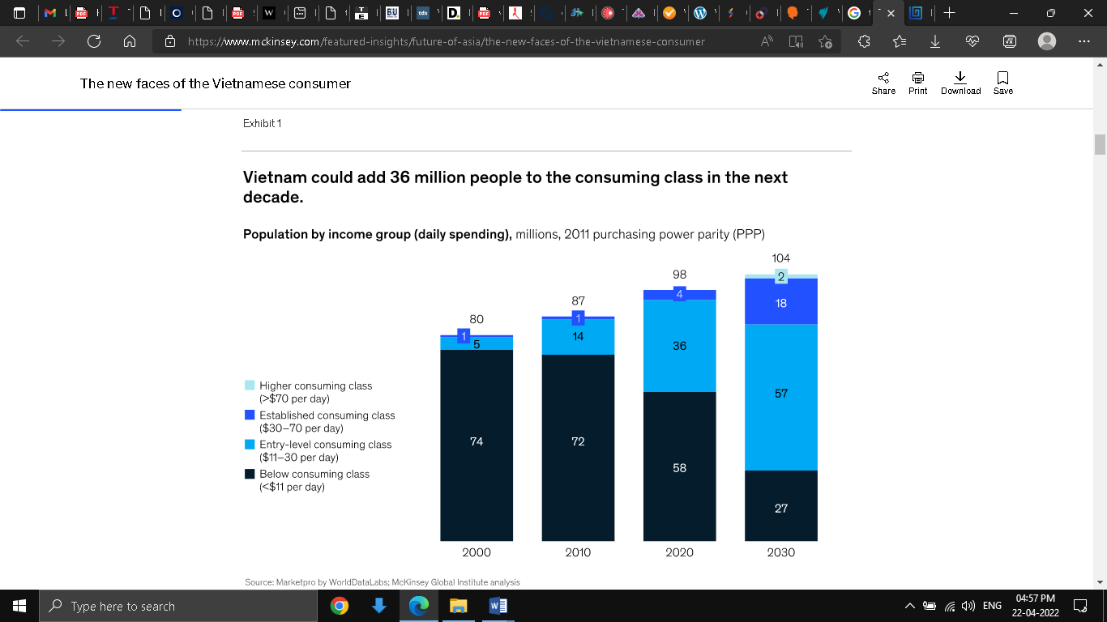

Fig 2: Population by income group

Source: (Vietnamese Consumer, 2021)

**Trompenaars’ 7 Cultural Dimensions**

Trompenaars’ 7 Cultural Dimension

(Source: Cultural Dimensions, 2022).

Trompenaars’ 7 Cultural Dimension opines that consumer across separate cultures act in ways which are specific and such specific differences can be predicted. The main features of Trompenaars’ 7 Cultural Dimensions are internal direction versus outer direction, universalism versus particularism, sequential time versus synchronous time, individualism versus communitarianism, achievement versus ascription, neutral versus emotional, and specific vs diffuse (Cultural Dimensions, 2022).

Instead of describing how individual cultural differences between UK and Vietnam affect the perception of the self-image of consumers in the market, a general understanding is projected using Trompenaars’ 7 Cultural Dimensions.

**Achievement versus ascription**

Reward and recognition is different cultures are viewed in different way. In cultures where the performance is the yardstick of measure then irrespective of the position of an individual in a society, he or she is recognised for that. This is in stark contrast with culture where the values are attributed to individual based on what other believe. In the present context, Vietnam culture has attributes that show ascription is more important than achievement. There are strata in the society based on various linguistic, economic and social position. Thus product or brand positioning should not be done in such a way that shows favouritism or criticism for any strata of the society. This is why customer targets should be well distributed across regions to avoid such errors in product positioning (Cultural Dimensions, 2022).

**Sequential time versus synchronous time**

Sequential time deems every event as separate and within certain time limits while synchronous time seems to events whether past, present or future as interwoven periods (Cultural Dimensions, 2022). Comparing the two different cultures it is evident that UK follows a sequential time while Vietnam follows the synchronous type of culture. This difference is important as the seasonal offerings and advertisements will become markedly different between the two countries. There are 14 different types of festivals in Vietnam, unlike in the UK or other EU countries. The presence of so many different types of festivals in a single calendar year creates a sensation where one festival begins while the other is still ending. A marked difference with UK. Thus product advertisements and seasonal offerings and discounts need to be fine-tuned more frequently to match the aspirations of the target customers.

**Universalism versus particularism**

Cultural practices and rules of land often complement and are dependent upon each other. In the context of Trompenaars’ dimension, this belongs to Particularism (Pirlog, 2021). For a significantly long time, the market structure of Vietnam was highly un-organised. This unorganised structure forms various formal and informal relationships between the producer, seller, and buyer. This is in stark contrast with the UK market structure which is more traditional, and layered. In short, the relationship that the customer shared with the market was built not over commercial values but with a relationship made of respect, care and emotions. This is vital from the market entry point of view for Tesco because the promotional strategies for entry need to be built focused on offering a sense of non-commercialized bonding. This kind of relationship takes time to make with customers, where customers feel they have more autonomy in their buying decisions.

**Individualism versus communitarianism**

The relationship between religion and rules and laws prevalent in a country has a direct correlation. Vietnamese culture has been primarily shaped by Buddhism. This has in turn shaped the laws of the land over decades. While European countries championed the cause of equal rights for every human being. Vietnam has long practised Communitarianism. Thus, putting the interest of the community or the group before one own individual need have been the front runner in shaping various cultural customs of Vietnam. This is another insight that should help Tesco identify that target customers are not individuals but rather groups or communities in a specific region or locality or town or city or village. Another aspect of communitarianism is the importance of allowing others to get involved in the decision-making process (Pirlog, 2021). Countries such as the UK and other European countries conduct polls from time to time either before launching a product or after the product is found. This is a technique that can be incorporated in the nascent stage of the market entry process. Thus, instead of presenting consumers with a set of products with a fixed price level. Polls can evaluate how the price sensitivity of customers change across different type of retail products. For example, the price sensitivity of customers based in the UK is markedly different from that of customers in Vietnam. This is explained with the example that consumers in Australia and US (Global Price Sensitive Consumer, 2022). A are more price-conscious when they are out eating with their children than they are when eating as couples. Again, in the context of emerging markets such as Vietnam, Cambodia, Philippines, it is more probable that consumers choose the lowest priced option in almost every category. While the same trend is not visible in the case of China and Brazil (Global Price Sensitive Consumer, 2022).

**Specific Versus diffuse relationship**

Public relations matter more in Vietnamese business culture than in the UK(Pirlog, 2021). A perfect example of how public relations matters can be given from even a non-Vietnamese company, but rather a USA based giant, the Apple. Apple understood the importance of public relations which is why right from the days of Steve Jobs, activities that built a bond between consumers of apple and Apple itself were one of its core focus areas. Taking the example of Apple, the importance of bonding with the customers becomes more important in the case of Vietnam. This is because the country is already predisposed to cultural practices that focus on building a relationship first before focusing on business objectives. This requires finding out more about the consumer’s needs and aspirations. This is in stark contrast with other developed countries that focus on strategic business objectives as a means to build a relationship with consumers. A marked difference between customer targeting in developing countries like Vietnam and that of developed countries like the UK is borne out of cultural differences. Personal relations play a vital role in business in Vietnamese culture. Again, in Vietnamese culture business relationships between two entities completely unknown usually take place through introductions facilitated by third parties. This shows another aspect of how important it is to create a relationship based on trust to gain customer confidence in a brand. This same concept applies to the word-of-mouth promotion. The consumers who are taken into confidence by building a relationship based on trust act as promotion multiplier, where their word of mouth conveyed to family, friends and relatives help Tesco to gain more trust among consumers.

# 4. Impact of cross-cultural issues on international marketing -mix strategy

The section explains the various marketing mix strategies that can be applied for proper product positioning and brand positioning. The ways cultural difference impact marketing mix strategy is also discussed. The marketing mix strategy in Vietnam is examined using the 4 Ps of marketing mix which are product, price, place and promotion.

## (i) Promotion strategy

Tesco can use this popularity as leverage to increase the effectiveness of its promotional campaign. It is already pointed out how Vietnamese are more community-oriented than individually focused (Carrasco, 2022). The promotional campaigns should be designed that addresses the need of a community than that of an individual basis. For example, selected products that are used on daily basis like as simple as rice and associated items that go with the preparation of other supporting dishes and serving plates and utensils can all be part of the campaign (Cateora et al., 2019). Vietnamese people have a different sense and style of cooking but separate from their European counterparts. This cooking usually takes place in an open space outside the house and under the natural shade of banana leaves or man-made constructions. This extravagant show of cooking sometimes even involves neighbours and other relatives, thus making it a community-based activity. Now it is not possible to create each community-specific promotion catalogue. But the general idea can be conveyed that indicates Tesco promotes community bonding. The Marcom strategy can be used for effective communication during promotional campaigns by Tesco Marketing Communication, 2022). In the above example of a simple product like rice, touch if done effectively can automatically position the brand by adjusting the customer’s perception about his or her association with the product. Association with rice creates a mental map of other dishes being served at family or community gatherings.

## (ii) Product strategy

The presence of a large number of players offering the same kind of product makes product differentiation harder. The product differentiation strategy used in UK and EU countries is different from that of Vietnam. For example, a product like a fish which is available in several countries including UK and Vietnam can be promoted to targeted customers differently through different product differentiation techniques like frozen, pre-cooked, fried, smashed, or even processed fish products to name a few. But the main principle based on which product differentiation is created in the first place is specific to the country and its underlying cultural practices (Timokhina et al., 2018). This distinction matters, because fish is consumed in different amounts and cooking styles in both UK and Vietnam. Fish may be found more frequently in Vietnamese dishes than in UK dishes. This brings the discussion to Philip Kotler’s product levels which can be even applied to a fish-based product. The 5 different levels of product perception starting from core benefit, generic, expected, augmented and potential will also differ from culture to culture. In the case of products with more diversified use, the different stages of how the product is perceived by consumers will vary even more depending on the underlying culture.

## (iii) Price strategy

It is pointed out in the previous section that consumers from developing economies are more sensitive to price changes. Thus, consumers are naturally inclined toward those products that seem to offer additional value at the exact cost. This propensity to change products and brands is driven by the notion of value-added which is again linked to product perception (Timokhina et al., 2018). For example, a home appliance product of Tesco like a rice cooker will have a different perceived value due to price changes in two other countries with vast cultural differences. A Rice cooker is considered an essential item in the Vietnamese household. The rice cooker has a sentimental value that cannot be judged through value addition or value reduction due to price changes. Thus, even though Vietnamese people are price sensitive but they may not exhibit the same in selecting a rice cooker brand. As this kind of sentimental relationship is built on trust, loyalty and dependency. In the same product, a significant price change in the UK can see the consumers switching their preference because of the different perceived value of a rice cooker. In short cultural differences create an extra product value perception. Thus, pricing strategy followed by one country can't be carried in a foreign country.

## (iv) Place strategy

The UK and other EU countries witnessed the earlier introduction of convenience stores, supermarkets and hyper stores in their market economy than Vietnam. It was only in 2002 that Metro Cash and Carry forayed into the Vietnam market. This proves to show that the idea of moving away from traditional stores to convenience stores took time to catch up in Vietnam. Although, Vietnam quickly caught up with the rest of the world in terms of the percentage of consumers using modern marketing ways such as supermarkets and hypermarkets (Vietnam Consumer Survey, 2022). In developed countries like the UK, more people have already started to shift to online mode of shopping more vigorously than before (UK Online Statistics, 2022). The slow transition of Vietnam is to some extent linked to its old cultural practice of shopping through haggling. Unlike now, shopping centres are centred around places of activity of an autonomous community. Thus, as Vietnam progressed, the traditional shops gave way to modern supermarkets. There is no haggling in supermarkets anymore, but people still enjoy the sense of buying through look, feel and smell. This engaging consumer activity provides an invigorating experience that hooks the consumer with the product. Drawing from this inference where more consumers are present in commercial centres and supermarkets than in online and traditional markets, the best place for product display of Tesco is a physical store.

# 5. Conclusion

The evaluation of the market environment of Thailand is based on the risks and opportunities for Tesco indicates that there is a relatively medium amount of risk. Although the opportunities outweigh the risk in the long run. Thus, the choice of market entry is suggested based on a long-term plan through a Greenfield venture. This will enable Tesco to set up a subsidiary unit supported by regional headquarter, production facilities, warehousing facility and cold storage chain. As this is a venture in Thailand which is culturally different from the parent company market in the UK, customer targeting and product or brand positing also follows differently. The customer level cross-cultural research indicates there is some marked difference between UK and Vietnam that affects the ways consumers perceive product value or brand value. This difference is also noticed in the ways companies built a relationship with customers. Based on the customer level cross-cultural evaluation a 4 P marketing mix strategy is suggested which focused on ways to address the customer that can be effective for product positioning. On one hand, the customer level cross-cultural difference invokes strategy innovation which can help Tesco align its products and services that best suit the consumers in Vietnam. On the other hand, there is also fear of gross miscalculation in understanding cross-cultural differences among customers of two different nations. Although the presence of foreign competitors in Vietnam provides a reassuring picture, some of them like Metro Cash and Carry which is operating for more than a decade. If these foreign retailer giants had not accounted for the cultural differences in product positioning strategies and market entry strategies, then they would not have survived for so long in a highly competitive market. This goes on to indicate that Tesco can benefit from expanding its business operations in Vietnam.

# 6. Reference

Cultural Dimension. (2022). Retrieved 23 April 2022, from https://www.mindtools.com/pages/article/seven-dimensions.htm

Alon, I., Elia, S., & Li, S. (2020). Greenfield or M&A? An institutional and learning perspective on the establishment mode choice of Chinese outward investments. Journal of International Management, 26(3), 100758. Retrieved 23 April 2022, from https://www.sciencedirect.com/science/article/pii/S1075425319303886

Bruijl, G. H. T. (2018). The relevance of Porter's five forces in today's innovative and changing business environment. Available at SSRN 3192207. Retrieved 23 April 2022, from https://papers.ssrn.com/sol3/papers.cfm?abstract_id=3192207

Carrasco, F. (2022). Understanding FMCG Promotions in Vietnam - Vietnamese - Kantar Worldpanel. Retrieved 23 April 2022, from <https://www.kantarworldpanel.com/vn/news/Understanding-FMCG-Promotions-in-Vietnam#download>

Cateora, P. R., Graham, J. L., Gilly, M. C., & Money, R. B. (2019). *International marketing: Philip R. cateora, R. bruce money, mary C. gilly, john L. graham* (18th ed.). McGraw-Hill Higher Education.

Chen, J., Sousa, C. M., & He, X. (2019). Export market re-entry: Time-out period and price/quality dynamisms. Journal of world business, 54(2), 154-168. Retrieved 23 April 2022, from https://www.sciencedirect.com/science/article/pii/S1090951618301779.

Doing Business Vietnam. (2022). Retrieved 23 April 2022, from https://tradingeconomics.com/vietnam/ease-of-doing-business

Global Price Sensitive Consumer. (2022). Retrieved 23 April 2022, from https://www.bcg.com/publications/2021/consumer-price-sensitivity

Grocery Shopping Vietnam. (2022). Retrieved 23 April 2022, from https://www.asiaperspective.com/rise-modern-grocery-shopping-vietnam/

Hameed, I., Zaman, U., Waris, I., & Shafique, O. (2021). A serial-mediation model to link entrepreneurship education and green entrepreneurial behavior: application of resource-based view and flow theory. International journal of environmental research and public health, 18(2), 550. Retrieved 23 April 2022, from https://www.mdpi.com/1660-4601/18/2/550/htm.

Hollender, L., Zapkau, F. B., & Schwens, C. (2017). SME foreign market entry mode choice and foreign venture performance: The moderating effect of international experience and product adaptation. *International Business Review*, 26(2), 250-263.

Market Entry: Metro Cash&Carry. (2022). Retrieved 23 April 2022, from https://investvietnam.vn/a-case-study-of-successful-vietnam-market-entry-metro-cash-carry-n139.html

Marketing Communication. (2022). Retrieved 23 April 2022, from https://learn.marsdd.com/article/what-is-marketing-communication-marcom/

Pirlog, A. (2021). National Cultural Profile in the Republic of Moldova According Hofstede and Trompenaars-Hampden-Turner Models. Revista de Management Comparat International, 22(4), 450-457. Retrieved 23 April 2022, from http://www.rmci.ase.ro/no22vol4/02.pdf

Retail in Vietnam. (2022). Retrieved 23 April 2022, from https://www2.deloitte.com/vn/en/pages/consumer-business/articles/vietnam-consumer-retail-2019.html

Tesco Annual Report. (2022). Retrieved 23 April 2022, from https://www.tescoplc.com/media/757589/tesco_annual_report_2021.pdf

Timokhina, G., Wagner, R., & Ürkmez, T. (2018). Cross-cultural variations in consumer behavior: A literature review of international studies. Retrieved 23 April 2022, from https://kobra.uni-kassel.de/bitstream/handle/123456789/13141/TimokhinaUerkmezWagnerCrossCulturalVariations.pdf?sequence=4.

UK Online Statistics. (2022). Retrieved 23 April 2022, from https://cybercrew.uk/blog/uk-online-shopping-statistics/#:~:text=In%202020%2C%2087%25%20of%20UK,the%20UK%20was%20only%2053%25.

Vietnam Consumer Survey. (2022). Retrieved 23 April 2022, from https://www2.deloitte.com/vn/en/pages/consumer-business/articles/vietnam-consumer-survey-2021.html

Vietnamese Consumer. (2021). Retrieved 23 April 2022, from https://www.mckinsey.com/featured-insights/future-of-asia/the-new-faces-of-the-vietnamese-consumer

Wang, W., & Ma, H. (2018). Export strategy, export intensity and learning: Integrating the resource perspective and institutional perspective. Journal of World Business, 53(4), 581-592. Retrieved 23 April 2022, from https://www.sciencedirect.com/science/article/abs/pii/S1090951617302377.

# 7. Appendix

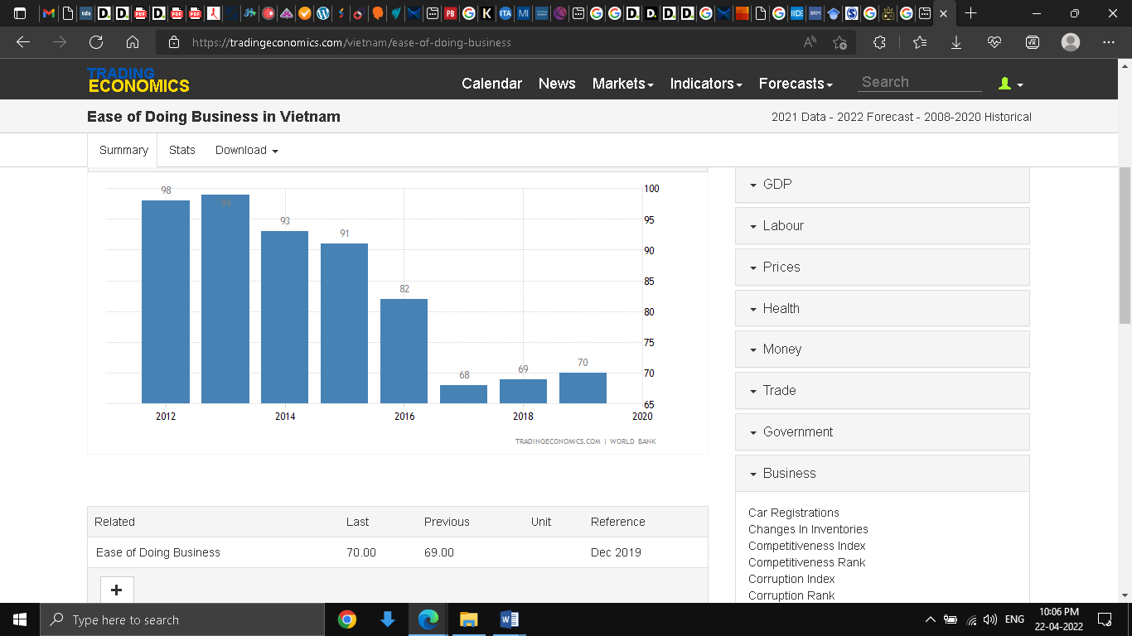

Table A: Vietnam Ease of Doing Business Rank 2012 to 2020

(Source: Doing Business Vietnam, 2022)

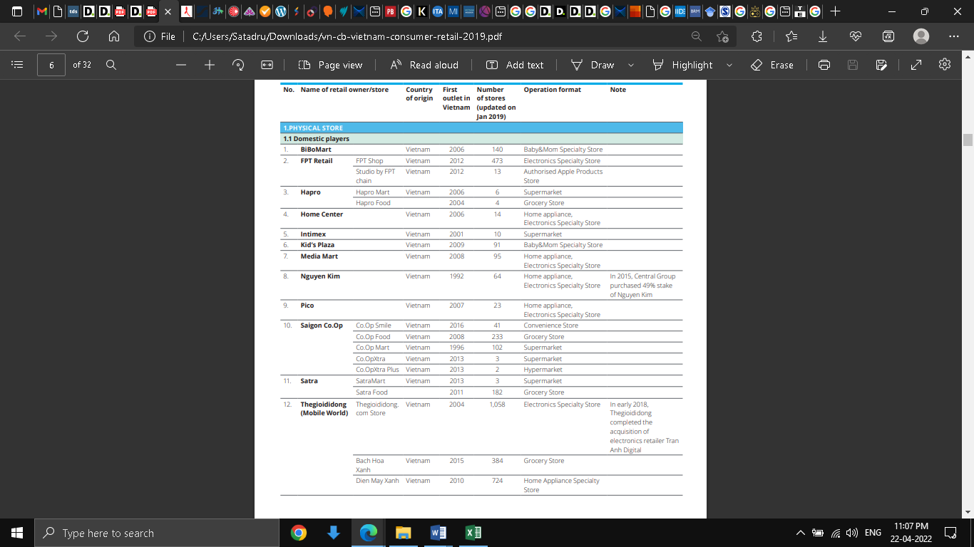

Table B: Vietnam Competitor Analysis

(Source: Retail in Vietnam, 2022)

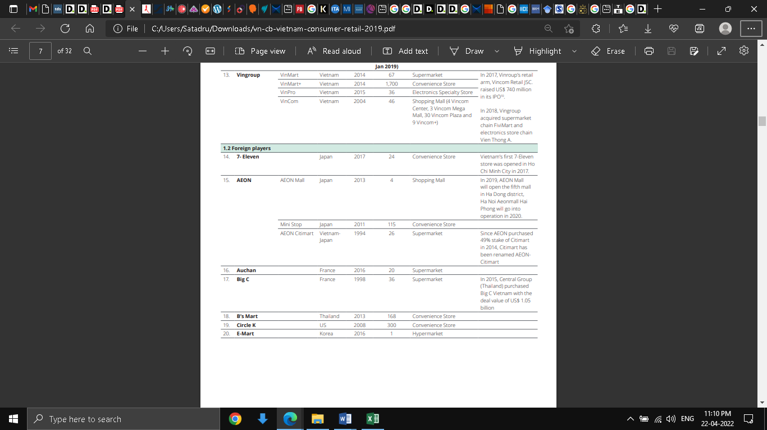

Table C: Vietnam Competitor Analysis

(Source: Retail in Vietnam, 2022)

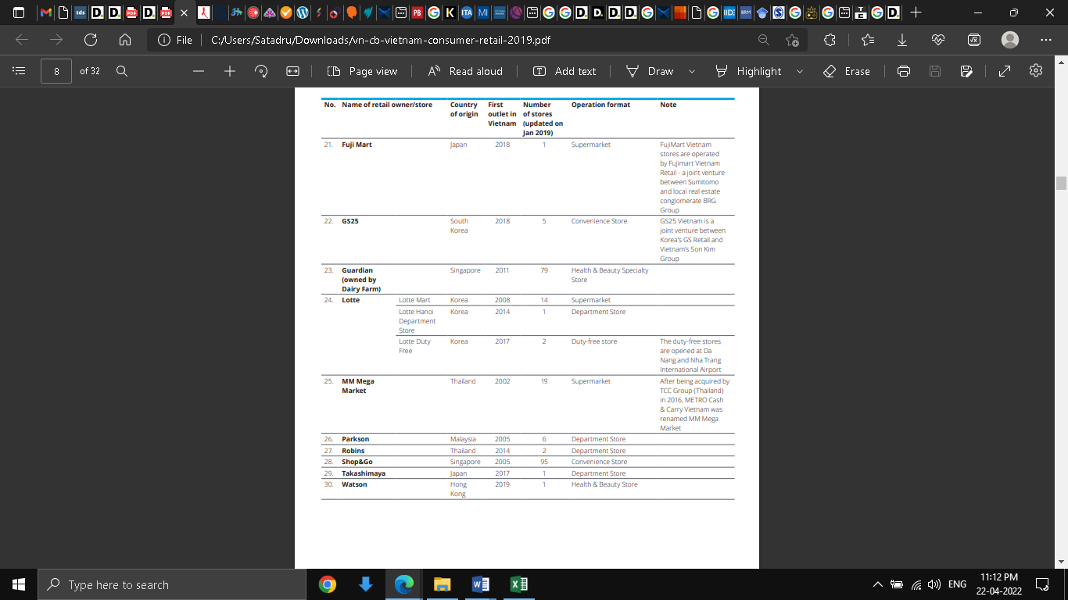

Table D: Vietnam Competitor Analysis

(Source: Retail in Vietnam, 2022)

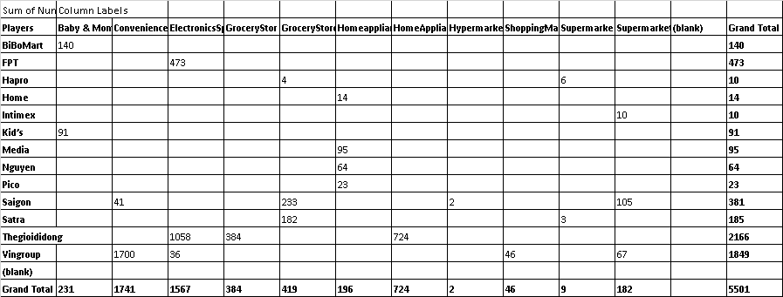

Table E: Vietnam Domestic Players and Physical Stores

Calculation based on data available data in Table B, Table C and Table D

(Source: Retail in Vietnam, 2022)

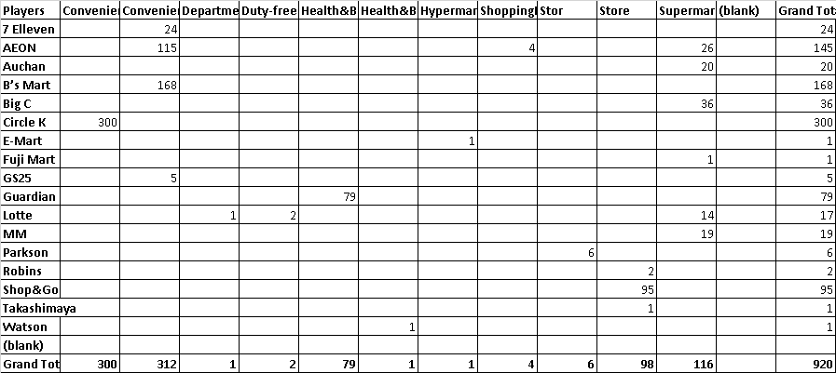

Table F: Vietnam Foreign Players and Physical Stores

Calculation based on data available data in Table B, Table C and Table D

(Source: Retail in Vietnam, 2022)